Euclidean Geometry
# Source: AI Source: Provided by: [Data Path: Persons Table -> ID Column: 1, Name_En Column: Motasem Essam] -> From: [ChatGPT] on [7/25/2026]
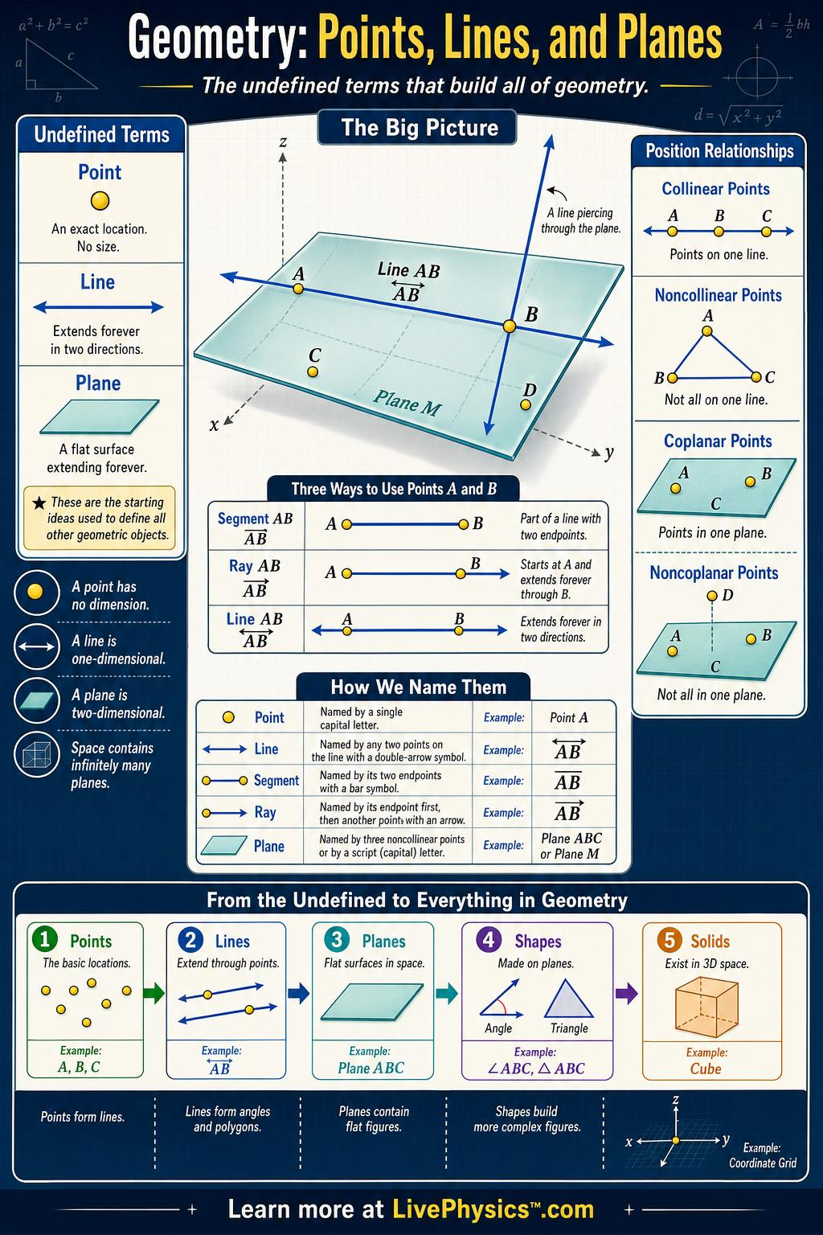
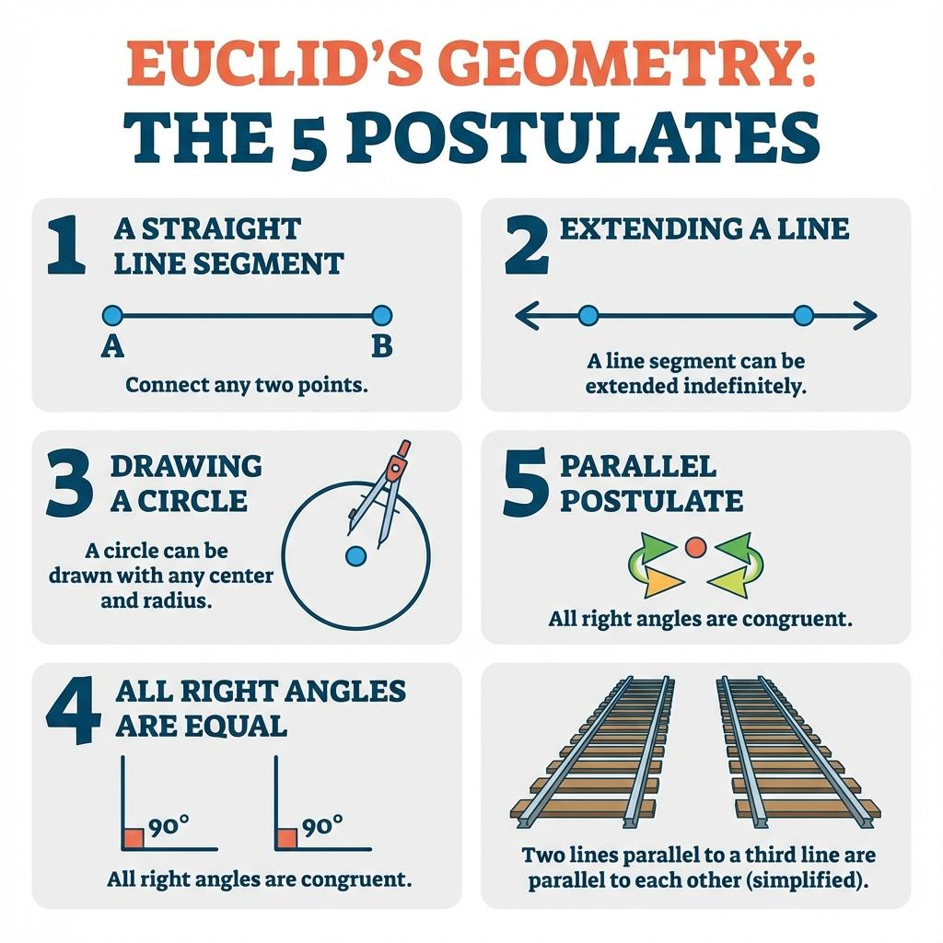
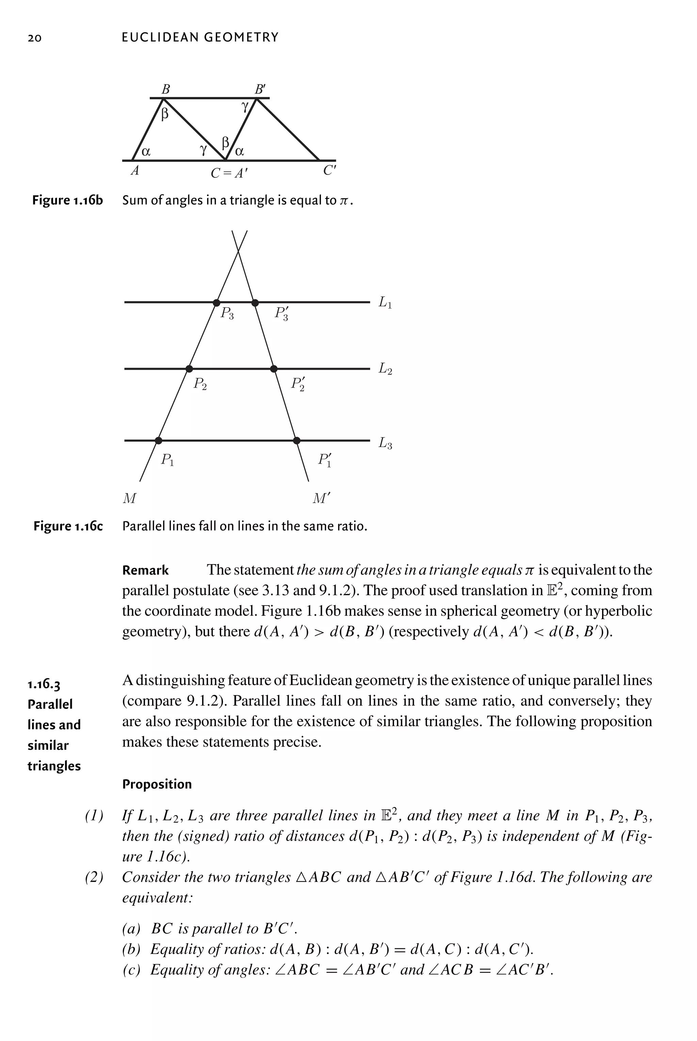
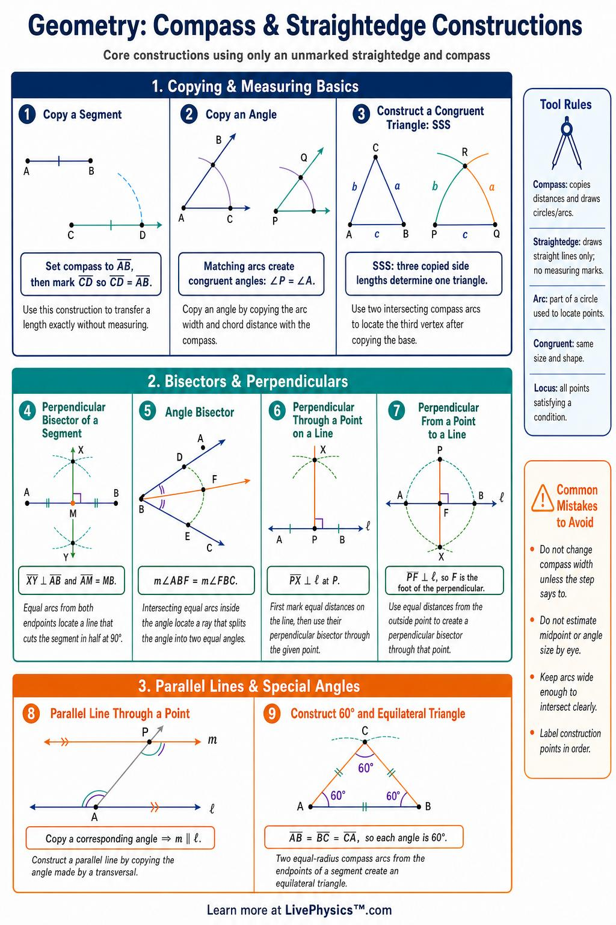
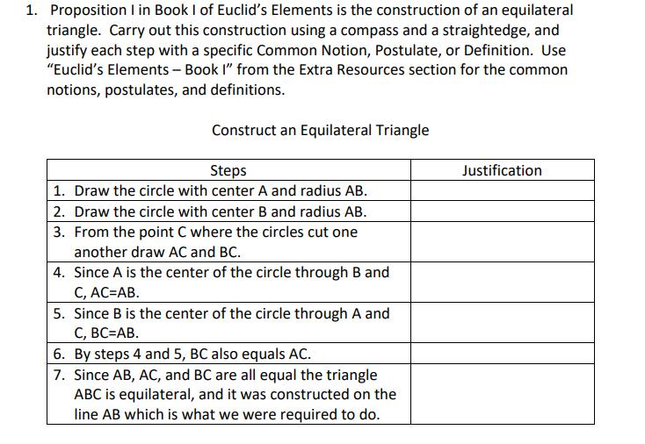

Definition
# Source: AI Source: Provided by: [Data Path: Persons Table -> ID Column: 1, Name_En Column: Motasem Essam] -> From: [ChatGPT] on [7/25/2026]
Euclidean Geometry is the branch of geometry based on the geometric principles, definitions, axioms, postulates, and theorems traditionally associated with Euclid.
It studies geometric objects and relationships in a flat (Euclidean) space, including:
- Points
- Lines
- Line segments
- Rays
- Angles
- Planes
- Triangles
- Polygons
- Circles
- Areas
- Lengths
- Volumes
- Parallel and perpendicular relationships
- Congruence
- Similarity
- Geometric transformations
Euclidean geometry is the geometry used in ordinary flat diagrams and is based on the assumption that parallel lines do not intersect.

Purpose
# Source: AI Source: Provided by: [Data Path: Persons Table -> ID Column: 1, Name_En Column: Motasem Essam] -> From: [ChatGPT] on [7/25/2026]
Euclidean Geometry is used to:
- Understand the fundamental structure of geometric space.
- Define and analyze geometric figures.
- Establish relationships between points, lines, angles, and shapes.
- Prove geometric statements using logical reasoning.
- Calculate lengths, angles, areas, and volumes.
- Study congruent and similar figures.
- Perform geometric constructions.
- Develop deductive reasoning and mathematical proof.

Fundamental Elements
# Source: AI Source: Provided by: [Data Path: Persons Table -> ID Column: 1, Name_En Column: Motasem Essam] -> From: [ChatGPT] on [7/25/2026]
Euclidean geometry is built from several fundamental concepts.

1. Point
# Source: AI Source: Provided by: [Data Path: Persons Table -> ID Column: 1, Name_En Column: Motasem Essam] -> From: [ChatGPT] on [7/25/2026]
A point represents an exact location in space.
It has:
- No length.
- No width.
- No thickness.
A point is commonly named with a capital letter:
$$A$$

2. Line
# Source: AI Source: Provided by: [Data Path: Persons Table -> ID Column: 1, Name_En Column: Motasem Essam] -> From: [ChatGPT] on [7/25/2026]
A line is a straight path extending infinitely in both directions.
It can be represented by:
$$\overset{↔}{AB}$$

3. Line Segment
# Source: AI Source: Provided by: [Data Path: Persons Table -> ID Column: 1, Name_En Column: Motasem Essam] -> From: [ChatGPT] on [7/25/2026]
A line segment is the portion of a line between two endpoints.
It is represented by:
$$\overset{‾}{AB}$$
Its length is:
$$AB$$

4. Ray
# Source: AI Source: Provided by: [Data Path: Persons Table -> ID Column: 1, Name_En Column: Motasem Essam] -> From: [ChatGPT] on [7/25/2026]
A ray starts at one endpoint and extends infinitely in one direction.
It is represented by:
$$\vec{AB}$$
where $A$is the endpoint.

5. Plane
# Source: AI Source: Provided by: [Data Path: Persons Table -> ID Column: 1, Name_En Column: Motasem Essam] -> From: [ChatGPT] on [7/25/2026]
A plane is a flat two-dimensional surface extending infinitely in all directions.
A plane can contain:
- Points
- Lines
- Segments
- Angles
- Polygons
- Circles

6. Angle
# Source: AI Source: Provided by: [Data Path: Persons Table -> ID Column: 1, Name_En Column: Motasem Essam] -> From: [ChatGPT] on [7/25/2026]
An angle is formed by two rays that share a common endpoint.
The common endpoint is the vertex.
For example:
$$∠ABC$$
has vertex $B$.

Euclid's Five Postulates
# Source: AI Source: Provided by: [Data Path: Persons Table -> ID Column: 1, Name_En Column: Motasem Essam] -> From: [ChatGPT] on [7/25/2026]
Classical Euclidean geometry is traditionally associated with Euclid's five postulates.

Postulate 1 — Straight Line
# Source: AI Source: Provided by: [Data Path: Persons Table -> ID Column: 1, Name_En Column: Motasem Essam] -> From: [ChatGPT] on [7/25/2026]
A straight line can be drawn from any point to any other point.

Postulate 2 — Extension
# Source: AI Source: Provided by: [Data Path: Persons Table -> ID Column: 1, Name_En Column: Motasem Essam] -> From: [ChatGPT] on [7/25/2026]
A finite straight line segment can be extended continuously in a straight line.

Postulate 3 — Circle
# Source: AI Source: Provided by: [Data Path: Persons Table -> ID Column: 1, Name_En Column: Motasem Essam] -> From: [ChatGPT] on [7/25/2026]
A circle can be constructed with any center and any radius.

Postulate 4 — Right Angles
# Source: AI Source: Provided by: [Data Path: Persons Table -> ID Column: 1, Name_En Column: Motasem Essam] -> From: [ChatGPT] on [7/25/2026]
All right angles are congruent.
Thus:
$${90}^{∘}={90}^{∘}$$

Postulate 5 — Parallel Postulate
# Source: AI Source: Provided by: [Data Path: Persons Table -> ID Column: 1, Name_En Column: Motasem Essam] -> From: [ChatGPT] on [7/25/2026]
If a line intersects two lines so that the interior angles on one side have a sum less than ${180}^{∘}$, then the two lines eventually intersect on that side.
This postulate is commonly expressed through the equivalent Playfair's axiom:
Through a point not on a given line, exactly one line can be drawn parallel to the given line.
This is one of the defining characteristics of Euclidean geometry.

Common Axioms
# Source: AI Source: Provided by: [Data Path: Persons Table -> ID Column: 1, Name_En Column: Motasem Essam] -> From: [ChatGPT] on [7/25/2026]
Euclidean geometry also uses basic axioms or common notions, such as:
- Things equal to the same thing are equal to each other.
- If equals are added to equals, the results are equal.
- If equals are subtracted from equals, the remainders are equal.
- Things that coincide with each other are equal.
- The whole is greater than the part.
These principles support geometric proofs.

Main Branches and Topics
# Source: AI Source: Provided by: [Data Path: Persons Table -> ID Column: 1, Name_En Column: Motasem Essam] -> From: [ChatGPT] on [7/25/2026]
Euclidean geometry contains many interconnected topics.
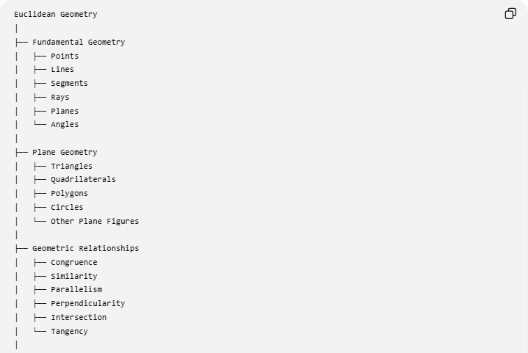
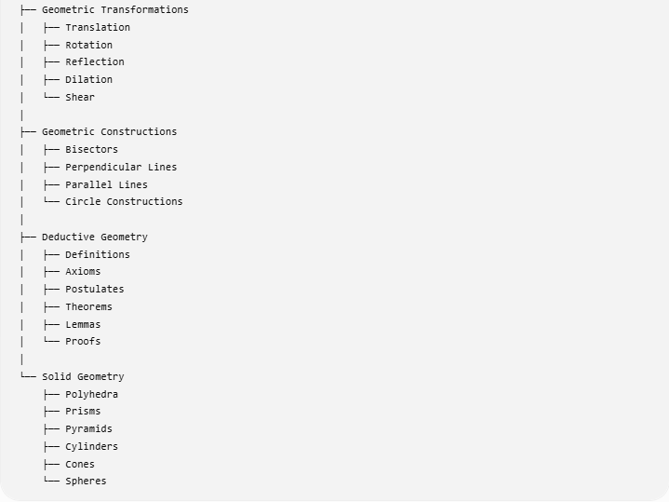
Euclidean Geometry
│
├── Fundamental Geometry
│ ├── Points
│ ├── Lines
│ ├── Segments
│ ├── Rays
│ ├── Planes
│ └── Angles
│
├── Plane Geometry
│ ├── Triangles
│ ├── Quadrilaterals
│ ├── Polygons
│ ├── Circles
│ └── Other Plane Figures
│
├── Geometric Relationships
│ ├── Congruence
│ ├── Similarity
│ ├── Parallelism
│ ├── Perpendicularity
│ ├── Intersection
│ └── Tangency
│
├── Geometric Transformations
│ ├── Translation
│ ├── Rotation
│ ├── Reflection
│ ├── Dilation
│ └── Shear
│
├── Geometric Constructions
│ ├── Bisectors
│ ├── Perpendicular Lines
│ ├── Parallel Lines
│ └── Circle Constructions
│
├── Deductive Geometry
│ ├── Definitions
│ ├── Axioms
│ ├── Postulates
│ ├── Theorems
│ ├── Lemmas
│ └── Proofs
│
└── Solid Geometry
├── Polyhedra
├── Prisms
├── Pyramids
├── Cylinders
├── Cones
└── Spheres

Plane Euclidean Geometry
# Source: AI Source: Provided by: [Data Path: Persons Table -> ID Column: 1, Name_En Column: Motasem Essam] -> From: [ChatGPT] on [7/25/2026]
Plane Geometry is the part of Euclidean geometry dealing primarily with two-dimensional figures.
It includes:
- Triangles
- Quadrilaterals
- Polygons
- Circles
- Angles
- Lines
- Areas
- Perimeters
For example, the triangle angle-sum theorem states:
$$\boxed{∠A+∠B+∠C={180}^{∘}}$$

Solid Euclidean Geometry
# Source: AI Source: Provided by: [Data Path: Persons Table -> ID Column: 1, Name_En Column: Motasem Essam] -> From: [ChatGPT] on [7/25/2026]
Solid Geometry extends Euclidean geometry to three-dimensional objects.
Examples include:
- Cubes
- Rectangular prisms
- Prisms
- Pyramids
- Cylinders
- Cones
- Spheres
For example, the volume of a rectangular prism is:
$$\boxed{V=lwh}$$

Important Euclidean Theorems
# Source: AI Source: Provided by: [Data Path: Persons Table -> ID Column: 1, Name_En Column: Motasem Essam] -> From: [ChatGPT] on [7/25/2026]
Many familiar geometry theorems belong to Euclidean geometry.
Triangle Angle Sum Theorem
$$\boxed{A+B+C={180}^{∘}}$$
Pythagorean Theorem
For a right triangle:
$$\boxed{a^{2}+b^{2}=c^{2}}$$
Exterior Angle Theorem
$$\boxed{\text{Exterior Angle}=\text{sum of the two remote interior angles}}$$
Triangle Proportionality Theorem
A line parallel to one side of a triangle divides the other two sides proportionally.
Angle Bisector Theorem
For triangle $ABC$, if $AD$bisects $∠A$:
$$\boxed{\frac{BD}{DC}=\frac{AB}{AC}}$$
Midsegment Theorem
A triangle's midsegment is parallel to the third side and has half its length:
$$\boxed{DE∥BC}$$
and:
$$\boxed{DE=\frac{1}{2}BC}$$

Euclidean Congruence
# Source: AI Source: Provided by: [Data Path: Persons Table -> ID Column: 1, Name_En Column: Motasem Essam] -> From: [ChatGPT] on [7/25/2026]
Two figures are congruent if they have the same shape and the same size.
For triangles, common congruence criteria include:
- SSS
- SAS
- ASA
- AAS
- HL for right triangles
For example:
$$△ABC≅△DEF$$
means corresponding sides and angles are congruent.

Euclidean Similarity
# Source: AI Source: Provided by: [Data Path: Persons Table -> ID Column: 1, Name_En Column: Motasem Essam] -> From: [ChatGPT] on [7/25/2026]
Two figures are similar if they have the same shape but may have different sizes.
Corresponding angles are congruent and corresponding lengths are proportional.
For similar triangles:
$$\frac{AB}{DE}=\frac{BC}{EF}=\frac{AC}{DF}$$

Parallelism
# Source: AI Source: Provided by: [Data Path: Persons Table -> ID Column: 1, Name_En Column: Motasem Essam] -> From: [ChatGPT] on [7/25/2026]
In Euclidean geometry, parallel lines lie in the same plane and never intersect.
$$\boxed{l_{1}∥l_{2}}$$
For parallel lines cut by a transversal, important relationships include:
- Corresponding angles
- Alternate interior angles
- Alternate exterior angles
- Same-side interior angles
The Euclidean parallel postulate is fundamental to these results.

Perpendicularity
# Source: AI Source: Provided by: [Data Path: Persons Table -> ID Column: 1, Name_En Column: Motasem Essam] -> From: [ChatGPT] on [7/25/2026]
Two lines are perpendicular when they intersect at a right angle.
$$\boxed{l_{1}⊥l_{2}}$$
and:
$$\boxed{θ={90}^{∘}}$$
Perpendicularity is important in:
- Altitudes
- Perpendicular bisectors
- Orthogonal projection
- Coordinate geometry
- Triangle centers

Euclidean Constructions
# Source: AI Source: Provided by: [Data Path: Persons Table -> ID Column: 1, Name_En Column: Motasem Essam] -> From: [ChatGPT] on [7/25/2026]
Classical Euclidean geometry uses idealized:
- Straightedge
- Compass
Common constructions include:
- Bisecting a segment.
- Bisecting an angle.
- Constructing perpendicular lines.
- Constructing parallel lines.
- Constructing regular polygons.
- Constructing circles.
- Copying an angle.

Deductive Structure
# Source: AI Source: Provided by: [Data Path: Persons Table -> ID Column: 1, Name_En Column: Motasem Essam] -> From: [ChatGPT] on [7/25/2026]
Euclidean geometry is strongly based on logical deduction.
A typical structure is:
$$\boxed{\text{Definitions + Axioms + Postulates}→\text{Theorems}→\text{Proofs}}$$
For example:
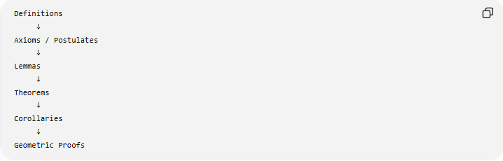
Definitions
↓
Axioms / Postulates
↓
Lemmas
↓
Theorems
↓
Corollaries
↓
Geometric Proofs

Example 1: Pythagorean Theorem
# Source: AI Source: Provided by: [Data Path: Persons Table -> ID Column: 1, Name_En Column: Motasem Essam] -> From: [ChatGPT] on [7/25/2026]
Suppose a right triangle has:
$$a=3$$
and:
$$b=4$$
Then:
$$a^{2}+b^{2}=c^{2} \\ 3^{2}+4^{2}=c^{2} \\ 9+16=c^{2} \\ 25=c^{2}$$
Therefore:
$$\boxed{c=5}$$

Example 2: Triangle Angle Sum
# Source: AI Source: Provided by: [Data Path: Persons Table -> ID Column: 1, Name_En Column: Motasem Essam] -> From: [ChatGPT] on [7/25/2026]
Suppose:
$$A={50}^{∘}$$
and:
$$B={60}^{∘}$$
Then:
$$A+B+C={180}^{∘} \\ {50}^{∘}+{60}^{∘}+C={180}^{∘} \\ C={70}^{∘}$$
Therefore:
$$\boxed{C={70}^{∘}}$$

Example 3: Parallel Lines
# Source: AI Source: Provided by: [Data Path: Persons Table -> ID Column: 1, Name_En Column: Motasem Essam] -> From: [ChatGPT] on [7/25/2026]
If two parallel lines are cut by a transversal and one corresponding angle is:
$${65}^{∘}$$
then its corresponding angle is also:
$$\boxed{{65}^{∘}}$$
because corresponding angles formed by a transversal of parallel lines are congruent.

Relationship with Other Geometries
# Source: AI Source: Provided by: [Data Path: Persons Table -> ID Column: 1, Name_En Column: Motasem Essam] -> From: [ChatGPT] on [7/25/2026]
Euclidean geometry is one of several major geometrical systems.
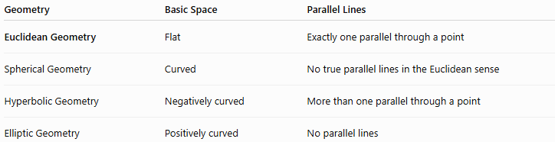
Geometry | Basic Space | Parallel Lines
Euclidean Geometry | Flat | Exactly one parallel through a point
Spherical Geometry | Curved | No true parallel lines in the Euclidean sense
Hyperbolic Geometry | Negatively curved | More than one parallel through a point
Elliptic Geometry | Positively curved | No parallel lines
The critical distinction is the treatment of the parallel postulate.

Euclidean Geometry vs Analytic Geometry
# Source: AI Source: Provided by: [Data Path: Persons Table -> ID Column: 1, Name_En Column: Motasem Essam] -> From: [ChatGPT] on [7/25/2026]
These two topics are closely related but are not identical.
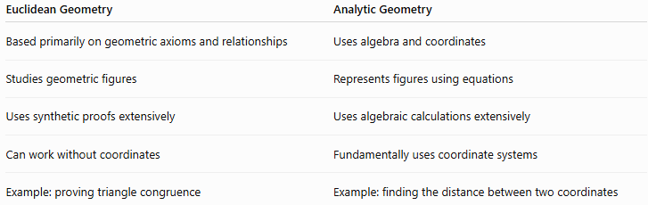
Euclidean Geometry | Analytic Geometry
Based primarily on geometric axioms and relationships | Uses algebra and coordinates
Studies geometric figures | Represents figures using equations
Uses synthetic proofs extensively | Uses algebraic calculations extensively
Can work without coordinates | Fundamentally uses coordinate systems
Example: proving triangle congruence | Example: finding the distance between two coordinates
Analytic geometry can therefore be viewed as a coordinate/algebraic approach to geometric problems, while Euclidean geometry is the broader geometric framework.

Euclidean Geometry vs Non-Euclidean Geometry
# Source: AI Source: Provided by: [Data Path: Persons Table -> ID Column: 1, Name_En Column: Motasem Essam] -> From: [ChatGPT] on [7/25/2026]
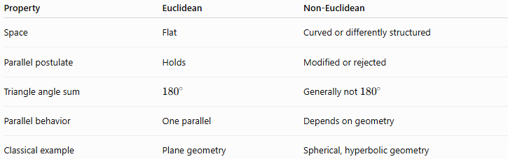
Property | Euclidean | Non-Euclidean
Space | Flat | Curved or differently structured
Parallel postulate | Holds | Modified or rejected
Triangle angle sum | $${180}^{∘}$$ | Generally not ${180}^{∘}$
Parallel behavior | One parallel | Depends on geometry
Classical example | Plane geometry | Spherical, hyperbolic geometry

Real-World Applications
# Source: AI Source: Provided by: [Data Path: Persons Table -> ID Column: 1, Name_En Column: Motasem Essam] -> From: [ChatGPT] on [7/25/2026]
Euclidean geometry is used in:
- Architecture.
- Construction.
- Engineering.
- Surveying.
- Computer graphics.
- Mechanical design.
- Land measurement.
- Technical drawing.
- Navigation and mapping.
- Manufacturing.
- Robotics.
- CAD systems.
For example, determining the dimensions of a rectangular room uses Euclidean relationships such as:
$$A=lw$$
and:
$$P=2\left(l+w\right)$$

Advantages
# Source: AI Source: Provided by: [Data Path: Persons Table -> ID Column: 1, Name_En Column: Motasem Essam] -> From: [ChatGPT] on [7/25/2026]
- Provides a rigorous foundation for classical geometry.
- Has a clear deductive structure.
- Supports precise geometric proofs.
- Provides powerful methods for calculating lengths, angles, areas, and volumes.
- Forms the foundation of much elementary and secondary-school geometry.
- Connects naturally with trigonometry, analytic geometry, and measurement.

Limitations
# Source: AI Source: Provided by: [Data Path: Persons Table -> ID Column: 1, Name_En Column: Motasem Essam] -> From: [ChatGPT] on [7/25/2026]
- It assumes a flat Euclidean space.
- It does not directly describe geometry on strongly curved surfaces.
- The Euclidean parallel postulate does not hold in non-Euclidean geometries.
- Some real-world spaces and physical systems require non-Euclidean or differential geometry for accurate modeling.

Relationship to Your Geometry Topics
# Source: AI Source: Provided by: [Data Path: Persons Table -> ID Column: 1, Name_En Column: Motasem Essam] -> From: [ChatGPT] on [7/25/2026]
For your existing knowledge-base structure, Euclidean Geometry should be a higher-level category, not merely another topic beside Triangle, Quadrilateral, Polygon, etc.
A useful hierarchy is:
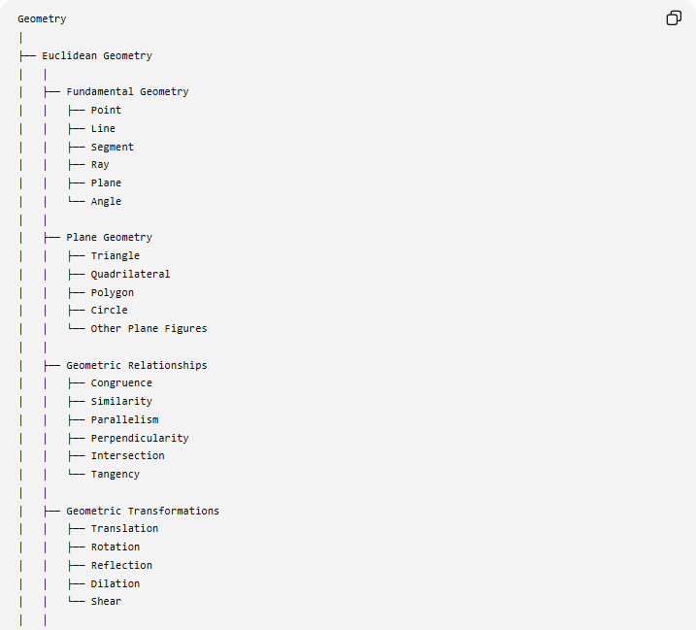
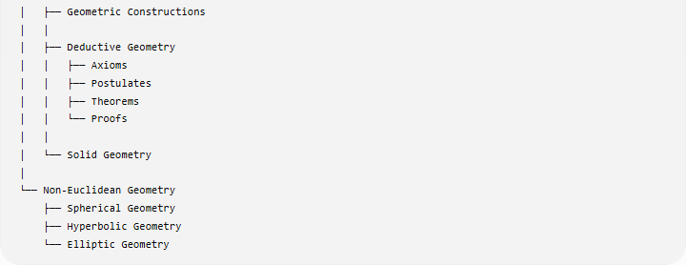
Geometry
│
├── Euclidean Geometry
│ │
│ ├── Fundamental Geometry
│ │ ├── Point
│ │ ├── Line
│ │ ├── Segment
│ │ ├── Ray
│ │ ├── Plane
│ │ └── Angle
│ │
│ ├── Plane Geometry
│ │ ├── Triangle
│ │ ├── Quadrilateral
│ │ ├── Polygon
│ │ ├── Circle
│ │ └── Other Plane Figures
│ │
│ ├── Geometric Relationships
│ │ ├── Congruence
│ │ ├── Similarity
│ │ ├── Parallelism
│ │ ├── Perpendicularity
│ │ ├── Intersection
│ │ └── Tangency
│ │
│ ├── Geometric Transformations
│ │ ├── Translation
│ │ ├── Rotation
│ │ ├── Reflection
│ │ ├── Dilation
│ │ └── Shear
│ │
│ ├── Geometric Constructions
│ │
│ ├── Deductive Geometry
│ │ ├── Axioms
│ │ ├── Postulates
│ │ ├── Theorems
│ │ └── Proofs
│ │
│ └── Solid Geometry
│
└── Non-Euclidean Geometry
├── Spherical Geometry
├── Hyperbolic Geometry
└── Elliptic Geometry

Important classification
# Source: AI Source: Provided by: [Data Path: Persons Table -> ID Column: 1, Name_En Column: Motasem Essam] -> From: [ChatGPT] on [7/25/2026]
Your existing topics such as Triangle, Quadrilateral, Polygon, Congruence, Similarity, Parallelism, Perpendicularity, Angle Bisector Theorem, Pythagorean Theorem, and Deductive Geometry Proof fit naturally within the Euclidean Geometry area.
However, Analytic Geometry is better kept as a separate major branch of Geometry, because it uses coordinates and algebra as its primary method:
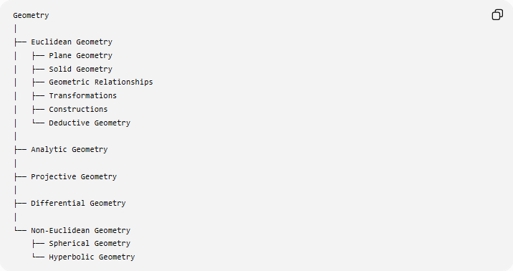
Geometry
│
├── Euclidean Geometry
│ ├── Plane Geometry
│ ├── Solid Geometry
│ ├── Geometric Relationships
│ ├── Transformations
│ ├── Constructions
│ └── Deductive Geometry
│
├── Analytic Geometry
│
├── Projective Geometry
│
├── Differential Geometry
│
└── Non-Euclidean Geometry
├── Spherical Geometry
└── Hyperbolic Geometry

Key Points
# Source: AI Source: Provided by: [Data Path: Persons Table -> ID Column: 1, Name_En Column: Motasem Essam] -> From: [ChatGPT] on [7/25/2026]
- Euclidean Geometry studies geometry in flat Euclidean space.
- It is traditionally based on Euclid's definitions, axioms, and five postulates.
- The parallel postulate distinguishes Euclidean geometry from many non-Euclidean geometries.
- Plane geometry and solid geometry are major parts of Euclidean geometry.
- Many classical results—such as the Triangle Angle Sum Theorem and Pythagorean Theorem—belong to Euclidean geometry.
- Euclidean geometry provides the foundation for much of classical geometric reasoning.
- Analytic Geometry is closely related but should be maintained as a separate branch in your taxonomy because its primary method is coordinates and algebra.

